**CSE 352**

**Web and Mobile Application Development Sessional**

**PROJECT REPORT**

**ON**

**“BOOKMART” A WEB APPLICATION**



**Hajee Mohammad Danesh Science & Technology University**

**Dinajpur**, **Bangladesh**

**August 2023**

**“BOOKMART” A WEB APPLICATION**

**BY**

**MD SABBIR HOSEN**

**ID: 1902040**

**CHIRANJIB CHAKRABORTY**

**ID: 1902059**

**MD. FIROZ ISLAM**

**ID: 1902057**

**This Report Presented in Partial Fulfilment of the Requirements for the Degree of Bachelor of Science in Computer Science and Engineering**

**Supervised By**

**Dr. Ashis Kumar Mandal**

Professor

Department of CSE, HSTU



**Hajee Mohammad Danesh Science & Technology University**

**Dinajpur**, **Bangladesh**

**ACKNOWLEDGEMENT**

We express our heartiest thanks and gratefulness to almighty Allah for His heavenly blessing for making us possible to complete the project successfully.We really grateful and wish our profound our indebtedness to Dr. Ashis Kumar Mandal, Professor, Department of CSE Hajee Mohammad Danesh Science and Technology University, Dinajpur. Deep Knowledge & keen interest of our supervisor in the field of “Web Development” to carry out this project. His endless guidance, continual encouragement, constant and energetic supervision, constructive criticism, valuable advice, reading many inferior drafts and correcting them at all stage have made it possible to complete this project.We would like to manifest my heartiest gratitude to Prof. Adiba Mahjabin Nitu, Chairman, Dept. of CSE for his kind help to finish our project and also to other faculty member and the staff of CSE department of Hajee Mohammad Danesh Science and Technology University.Finally, we must acknowledge with due respect the constant support and patients of our parents**.**

**ABSTRACT**

The "BookMart" web application is a comprehensive platform designed to revolutionize the way users discover, purchase, and engage with books online. In a rapidly digitizing world, the traditional brick-and-mortar bookstore model is evolving to meet the demands of modern readers. BookMart addresses this shift by providing a user-friendly and immersive online environment that offers an extensive collection of books across various genres.The primary objective of the BookMart web application is to create an intuitive and interactive platform for book enthusiasts to explore, select, and purchase books seamlessly. Users can create personalized profiles, allowing them to curate reading preferences, track reading history, and receive tailored book recommendations. The application also features secure payment gateways to facilitate smooth transactions and a user-friendly interface that ensures a satisfying browsing experience

**TABLE OF CONTENTS**

**CONTENTS PAGE**

Title page 2

Acknowledgement 3

Abstract 4

Table of Contents 5-7

List of Figures 8

**CHAPTER 1: INTRODUCTION 9-10**

* 1. Introduction 9
  2. Motivation 9
  3. Goal of the Project 9-10
  4. Scope 10
  5. Methodology 10-11
  6. Organization of the Report 11

**CHAPTER 2: BACKGROUND ANALYSIS 11-12**

* 1. Introduction 11
  2. Changing Reading Patterns 11
  3. Digital Convenience and Exploration 12
  4. User-Centric Engagement 12
  5. Secure Transactions and E-Commerce 12
  6. Responsive and Accessible Design 13
  7. Community and Social Integration 13
  8. Challenges of This Project 13
  9. Conclusion 13

**CONTENTS PAGE**

**CHAPTER 3: SYSTEM ANALYSIS & REQUIREMENT 14-17**

**SPECIFICATION**

3.1 Application Process Modelling 14-15

3.2 Requirement Analysis 15-16

3.3 Hardware and Software Requirements 17

3.4 Design and Model requirements 17

**CHAPTER 4: SYSTEM DESIGN 18-21**

4.1 Use Case Modelling 18-19

4.2 System Context Diagram 19-21

4.3 E-R Diagram 21

**CHAPTER 5: DESIGN SPECIFICATION 22-30**

5.1 Technology Stack 19

5.2 System Components 20

5.1.2 Snapshot of manage product panel 20

5.1.3 Snapshot of update Admin Password panel 21

5.1.4 Snapshot of manage sellers panel 21

5.1.5 Snapshot of manage category panel 22

5.1.6 Snapshot of manage Billing point 22

5.1.7 Snapshot of manage Database 23

**CONTENTS PAGE**

**CHAPTER 6: IMPLEMENTATION & TESTING 31-33**

6.1 Database Setup 31

6.2 Frontend Development 31

6.3 Backend Development 31-32

6.4 Testing Implementation 32

6.4.1 Unit Testing 32

6.4.2 Integration Testing 32

6.4.3 User Testing 33

**CHAPTER 7: CONCLUSION AND FUTURE SCOPE 34-35**

7.1 Achievements 34

7.2 Future Enhancements 34-35

**REFERENCE**

**LIST OF FIGURES**

**FIGURES PAGE NO**

**Figure 4.1.1:** Use Case Diagram of User 18

**Figure 4.1.2:** Use Case of Admin 19

**Figure 4.2.1:** Level-0 Context Diagram of “BookMart” 19

**Figure 4.2.2:** Level-1 Context Diagram of “BookMart” 20

**Figure 4.2.3:** Level-2 Context Diagram (Admin View) 20

**Figure 4.2.4:** Level-2 Context Diagram (User View) 24

**Figure 4.3.1:** Entity-Relationship Diagram 21

**Figure 5.2.1:** Home Page of User Panel 23

**Figure 5.2.2:** Registration Page 23

**Figure 5.2.3:** login Page 24

**Figure 5.2.4:** Shop Page of User Panel 24

**Figure 5.2.5:** Search Page of User Panel 25

**Figure 5.2.6:** Order Page of User Panel 25

**Figure 5.2.7:** Adding to Cart Page of User Panel 26

**Figure 5.2.8:** Checkout and Payment Page of User Panel 26

**Figure 5.2.9:** About Page of User Panel 27

**Figure 5.2.10:** Contact page of User Panel 27

**Figure 5.2.11:** Admin Page of Admin Panel 28

**Figure 5.2.12:** Product Page of Admin Panel 29

**Figure 5.2.13:** Order Page of Admin Panel 29

**Figure 5.2.14:** Massage page of User Pannel 29

**Figure 5.2.15:** Database 30

**CHAPTER 1**

**INTRODUCTION**

* 1. **Introduction:**

In the era of digital transformation, where technology permeates every facet of our lives, the way we discover, purchase, and interact with books has also undergone a significant evolution. The advent of web applications has revolutionized the reading experience, enabling book enthusiasts to explore vast literary landscapes from the comfort of their screens. This project introduces "Book-Mart," a pioneering web application poised to reshape the landscape of online book discovery and engagement.

* 1. **Motivation:**

The inspiration behind the creation of the Book-Mart web application stems from the evolving dynamics of the publishing and reading industries. Traditional bookstores have long been a haven for bibliophiles, fostering a sense of community and discovery. However, with the advent of e-commerce and the digital reading experience, there is a growing demand for a digital equivalent that captures the essence of traditional bookstores while harnessing the power of technology.

Book-Mart emerges as a response to this demand, providing an online platform that combines the richness of physical bookstores with the convenience and accessibility of the digital realm. By seamlessly blending an extensive collection of books with user-friendly features, Book-Mart aims to connect readers with their literary passions and introduce them to new realms of literature.

* 1. **Goal of The Project:** The "Project Objectives" section outlines the specific goals and functionalities that the "Book-Mart" web application aims to achieve. These objectives provide a clear roadmap for what the project intends to deliver. The stated objectives for the "Book-Mart" application are:

**1. Develop an E-Commerce Platform for Selling Books Online:** The primary objective of the project is to create an e-commerce platform dedicated to the sale of books. This platform will allow users to explore a wide range of books and make purchases from the comfort of their homes.

**2. User Registration, Login, and Account Management:**  The application will provide a user registration and login system to allow users to create accounts and log in securely. Users will also be able to manage their account information.

**3. User-Friendly Interface for Browsing and Searching Books:**  The application will offer an intuitive and user-friendly interface that enables users to browse and search for books based on their interests.

**4. Shopping Cart System:** A shopping cart feature will be implemented, allowing users to add selected books to their cart while continuing to browse. This feature facilitates the shopping experience by enabling users to review and manage their selected items.

**5. Order Placement and Order History:** The application will allow users to place orders for selected books and keep track of their order history. Users can view details of past orders they have made.

**6. Admin Panel for Product and Order Management:** An admin panel will be created to facilitate the management of products available for sale and orders placed by users. Admins will have the ability to add, edit, and delete products, as well as manage orders.

1. **Scope:**

The scope of the Book-Mart web application project encompasses the development of feature-rich platform that incorporates essential elements such as an expansive book catalogue, personalized recommendation algorithms, user profiles, secure payment gateways, and a user-centric interface. The project will focus on creating a responsive and dynamic application that adapts seamlessly to various devices, ensuring that users can engage with their favourite books anytime and anywhere.

1. **Methodology:**

The development of the Book-Mart web application follows a systematic methodology that involves phases of research, design, implementation, testing, and deployment. Collaboration between front-end and back-end development teams ensures a cohesive user experience and robust functionality. Advanced recommendation algorithms will be employed to enhance user engagement and satisfaction, while stringent security measures will be implemented to safeguard user data and transactions.

* 1. **Organization of the Report:**

This project report is structured to provide a comprehensive overview of the Book-Mart web application, covering its design, development, key features, implementation details, challenges faced, and outcomes achieved. The subsequent sections delve into the methodology, technical aspects, and user experience considerations that have shaped the project's evolution.

In summary, the Book-Mart web application project aims to redefine the online book discovery experience by fusing the charm of traditional bookstores with the convenience of the digital age. Through innovative design, advanced technology, and user-centric features, Book-Mart seeks to carve a niche as a premier destination for readers seeking to explore, engage, and immerse themselves in the world of literature.

**CHAPTER 2**

**BACKGROUND ANALYSIS**

* 1. **Introduction:**

The "Book-Mart" web application emerges as an innovative response to the evolving

landscape of the book industry, driven by the fusion of modern technology and changing consumer preferences. This background analysis delves into the factors that inspire the creation of the "Book-Mart" application, its potential to reshape online book experiences, and the significance of its technological components**.**

* 1. **Changing Reading Patterns:**

The way people engage with literature has been undergoing a significant transformation. E-books, audiobooks, and digital reading platforms have become integral to modern reading habits. As more readers turn to online avenues for accessing books, the traditional model of brick-and-mortar bookstores faces new challenges

* 1. **Digital Convenience and Exploration:**

Digitalization brings convenience and immediate access to a wide range of literary works. The "Book-Mart" web application aims to provide readers with a user-friendly platform that mirrors the sensory experience of browsing physical bookshelves while harnessing the convenience and accessibility of the digital realm.

* 1. **User-Centric Engagement:**

Modern users expect engaging and personalized online experiences. The integration of HTML, CSS, Tailwind CSS, JavaScript, and PHP empowers "Book-Mart" to deliver dynamic web pages with visually appealing designs. These technologies allow for the creation of interactive elements, personalization features, and seamless user interactions.

* 1. **Secure Transactions and E-Commerce:**

With the integration of PHP, the "Book-Mart" application gains the capability to manage secure e-commerce transactions. Users can safely purchase their selected books through a trusted and efficient payment gateway. PHP's backend support ensures that transactions are processed securely, enhancing user confidence.

* 1. **Responsive and Accessible Design:**

The combination of HTML, CSS, and Tailwind CSS facilitates the development of a responsive design that adapts seamlessly to different devices and screen sizes. "Book-Mart" becomes accessible to users whether they're browsing from a desktop, tablet, or smartphone, ensuring an optimal user experience.

* 1. **Community and Social Integration:**

JavaScript empowers "Book-Mart" with interactive features that promote user engagement and community building. Users can rate and review books, create reading lists, and share recommendations. This dynamic interaction fosters a sense of community, mirroring the social aspect of physical bookstores.

* 1. **Challenges of This Project**

This project has many challenges. The main challenge my projects is assure security. The other challenges are given there:

* Efficiency should be maintained.
* user interface (UI) design should be suitable.
* Exact data must be maintained
* Database conjunction and data passing should be maintained
* Approval should be maintained.
* Reactivity should be maintained.
* Accurate contract should be maintained.
  1. **Conclusion:**

In conclusion, the "Book-Mart" web application project addresses the evolving needs of readers by merging traditional bookstore experiences with the digital realm. The application's strategic use of HTML, CSS, Tailwind CSS, JavaScript, and PHP enables the creation of an immersive, user-centric, and secure platform for discovering, purchasing, and engaging with books online. "Book-Mart" seeks to redefine the digital book discovery process, catering to the preferences of modern readers while preserving the essence of literary exploration.

**CHAPTER 3**

**SYSTEM ANALYSIS & REQUIREMENT SPECIFICATION**

1. **Application Process Modelling: "Book-Mart" Web Application**
2. **User Registration and Authentication:**

* User registers an account with personal information.
* System validates the information and creates the user profile.
* User logs in with credentials for access to personalized features.

1. **Browsing and Searching for Books:**

* User navigates through the book catalogue.
* User utilizes search and filter options to find specific books or genres.
* System presents a list of books based on search criteria.

1. **Viewing Book Details:**

* User clicks on a book to view its details.
* System displays book information, cover image, synopsis, and reviews.
* Personalized Recommendations:
* System analyses user's reading history and preferences.
* System generates personalized book recommendations.
* User can explore recommended books and add them to their reading list.

1. **Adding Books to Cart:**

* User selects books they want to purchase.
* System adds selected books to the user's shopping cart.
* User can review the cart contents before proceeding.

1. **Checkout and Payment:**

* User proceeds to checkout.
* System calculates the total cost, including taxes and shipping.
* User provides payment information and confirms the purchase.
* PHP backend processes the payment securely.

1. **Order Confirmation:**

* System generates an order confirmation with details.
* User receives an email confirmation with order information.

1. **User Reviews and Interaction:**

* Users can rate and leave reviews for books.
* Users can comment on reviews and engage in discussions.
* JavaScript enables dynamic interactions for user engagement.

1. **User Profile Management:**

* User can access their profile settings.
* User updates personal information, preferences, and reading history.
* User can view their reading history and saved books.

1. **Logging Out:**

* User logs out to end the session.

1. **Requirement Analysis:**
2. **User Registration:**

* Users can create accounts with personal details.
* Validation for unique usernames and email addresses.

1. **Authentication and Login:**

* Users can log in using their credentials.
* Password hashing and secure authentication.

1. **Book Catalogue:**

* An extensive collection of books categorized by genres.
* Book details include title, author, cover image, and synopsis.

1. **Search and Filters:**

* Users can search for books by title, author, or keywords.
* Filters by genre, author, rating, and publication date.

1. **Personalized Recommendations:**

* System suggests books based on user preferences and reading history.

1. **Book Details:**

* Detailed book pages with information, cover images, and reviews.
* User reviews and ratings displayed on book pages.

1. **Shopping Cart:**

* Users can add books to their cart for purchase.
* Display of cart contents, total cost, and quantity.

1. **Checkout and Payment:**

* Secure payment processing with PHP backend.
* Options for payment methods and address input.

1. **Order Confirmation:**

* System generates order confirmations with details.
* Users receive email confirmations.

1. **User Profiles:**

* User profiles with saved preferences, reading history, and reviews.
* Editing and updating profile information.

1. **User Interaction:**

* Users can rate books, leave reviews, and comment on reviews.
* Dynamic interactions using JavaScript for user engagement.

1. **Responsive Design:**

* Application adapts to different devices and screen sizes.

1. **Secure Transactions:**

* Encryption and secure protocols for user data and payments.

1. **Community Features:**

* User-generated content for discussions and recommendations.
* Interaction through comments and replies.

1. **Accessibility:**

* Ensure the application is usable by people with disabilities.

1. **Admin Panel (if applicable):**

* Admin interface to manage books, reviews, and users.
* Content management for book additions and updates.

1. **Performance and Scalability:**

* Application should handle multiple users and concurrent transactions.

1. **Testing:**

* Comprehensive testing for functionality, security, and user experience.

1. **Deployment:**

* Successful deployment of the application on a web server.

1. **Hardware and Software Requirements:**

**Hardware Requirements:**

* Storage: Minimum 1.5GB Storage.
* Ram: 4GB.
* Laptop, Desktop

**Software Requirement:**

* Language: PHP, JavaScript
* For Design: HTML, Tailwind CSS, DaisyUI
* Database: MariaDB
* Platform: Visual Studio Code
* Operating System: Windows, Linux.

1. **Design and Model requirements:**

This system has two panel, admin panel and user panel. If user want to proper output, then the database design would have been perfectible and systematic way. The system has various part for data storage where the information could be sort by systematic way.

**CHAPTER 4**

**SYSTEM ARCHITECTURE**

1. **User Case Modelling:**

A user case model describes different types of users interacts and their activities into a system. It is also a list of action which done by the user. The number of elements like as: An actor, an event, a use case. The major component is the actor.

we have two in my projects, they are:

* User

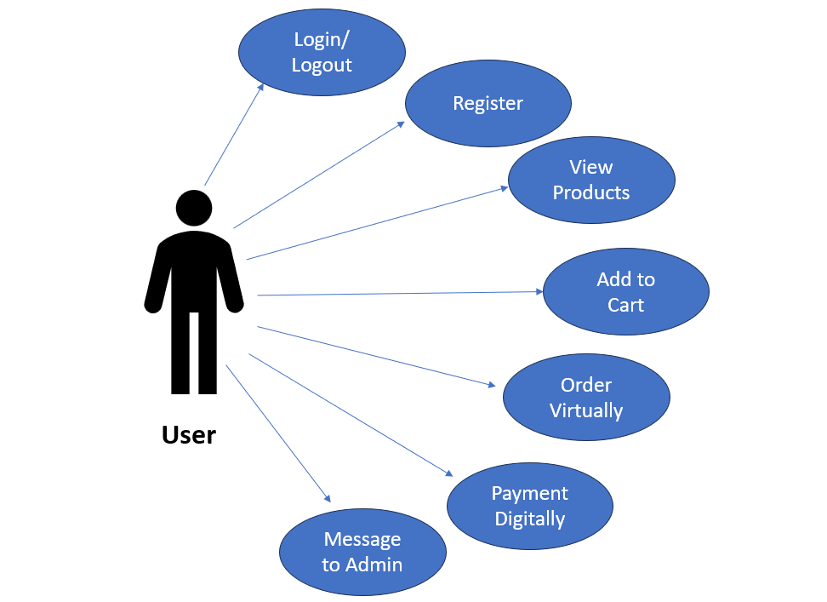

**Figure 4.1.1:** Use Case Diagram of User

* Admin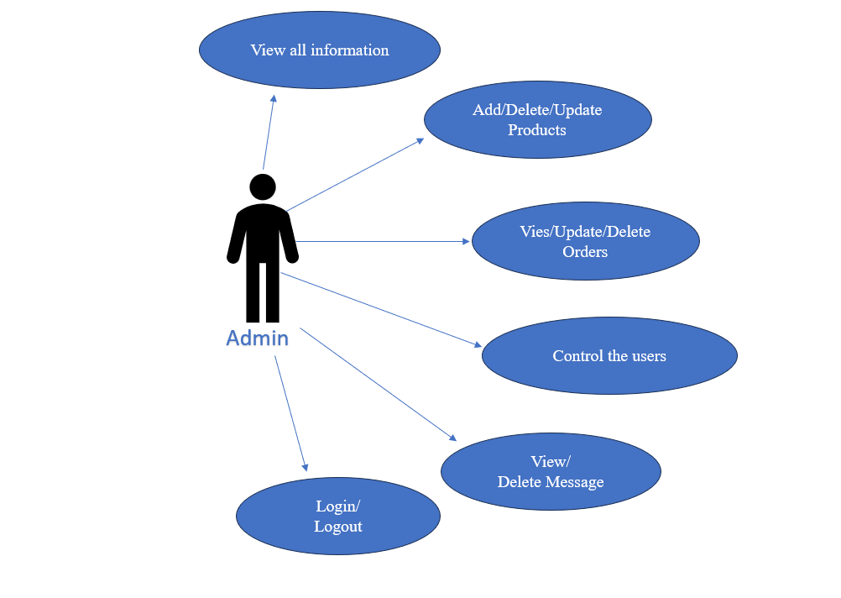

**Figure 4.1.2:** Use Case Diagram of Admin

1. **Context Diagram:**

A Context Diagram is the highest level of data flow diagram. It represents the flows of information between the system and all external entities that may have interact with a system. The entire software system is shown as a single process.

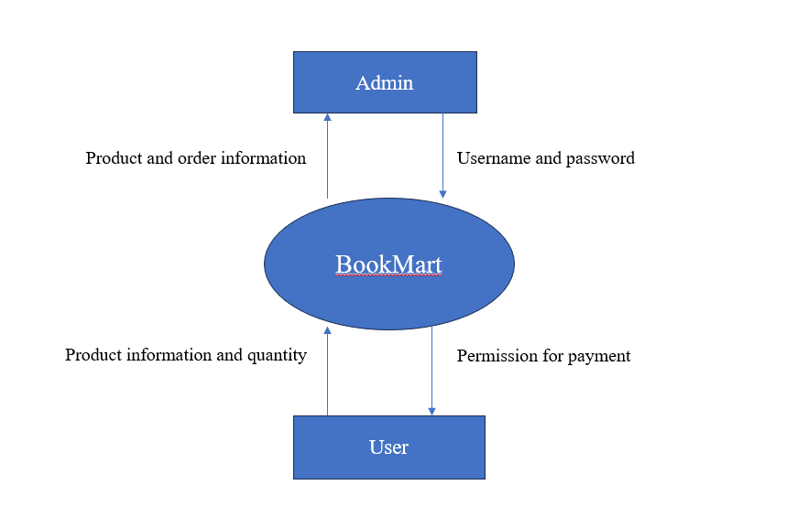

**Figure 4.2.1:** Level-0 Context Diagram of ‘BookMart’

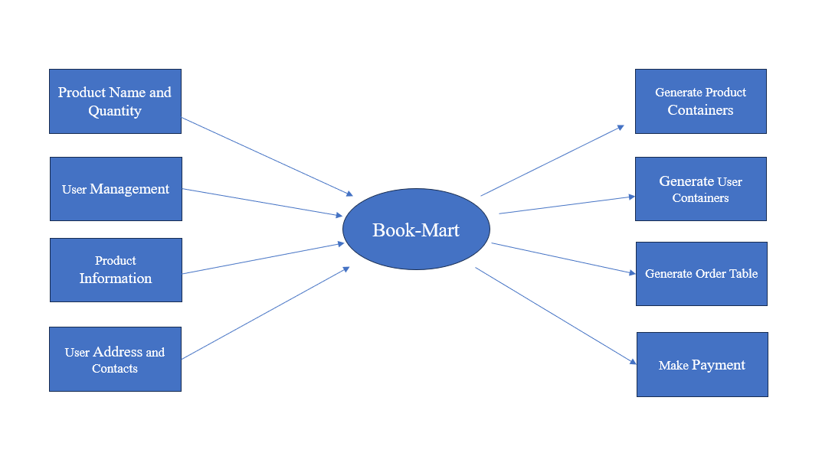

**Figure 4.2.2:** Level-1 Context Diagram of ‘BookMart’

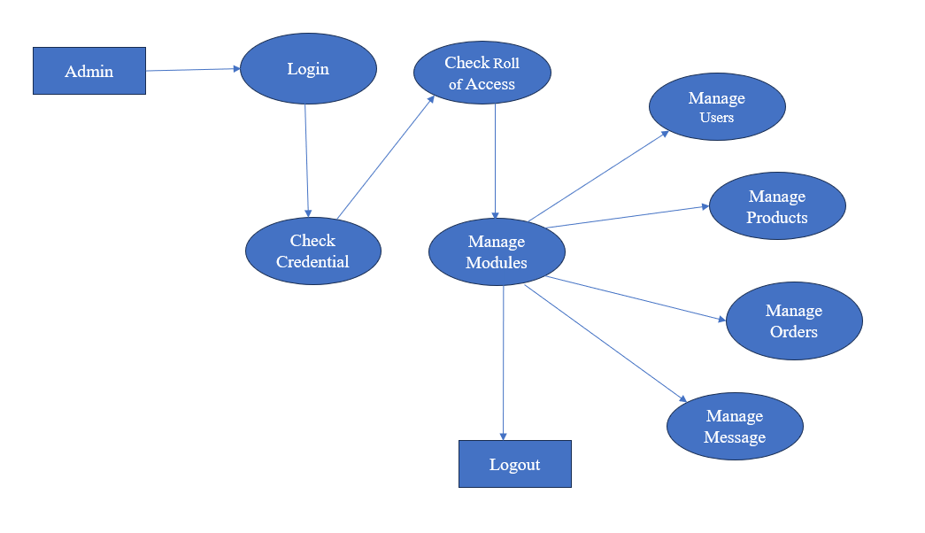

**Figure 4.2.3:** Level-2 Context Diagram (Admin view)

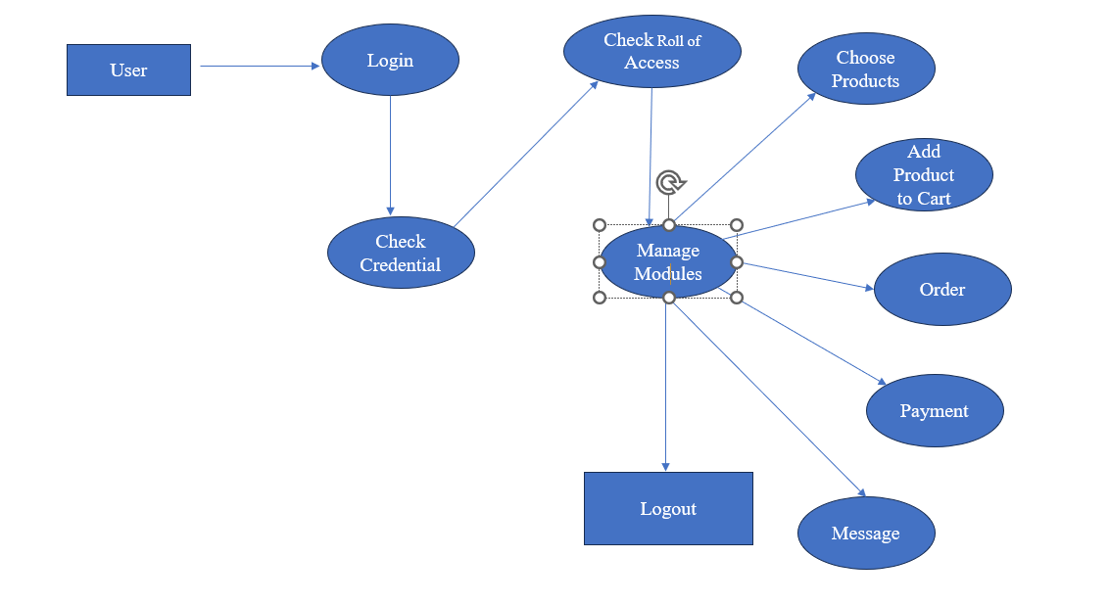

**Figure 4.2.4:** Level-2 Context Diagram (User view)

* 1. **E-R diagram:**

E-R diagram is entity relationship diagram which can describes interrelated things of interest in specific domain of knowledge.

E-R diagrams of this system are given below.

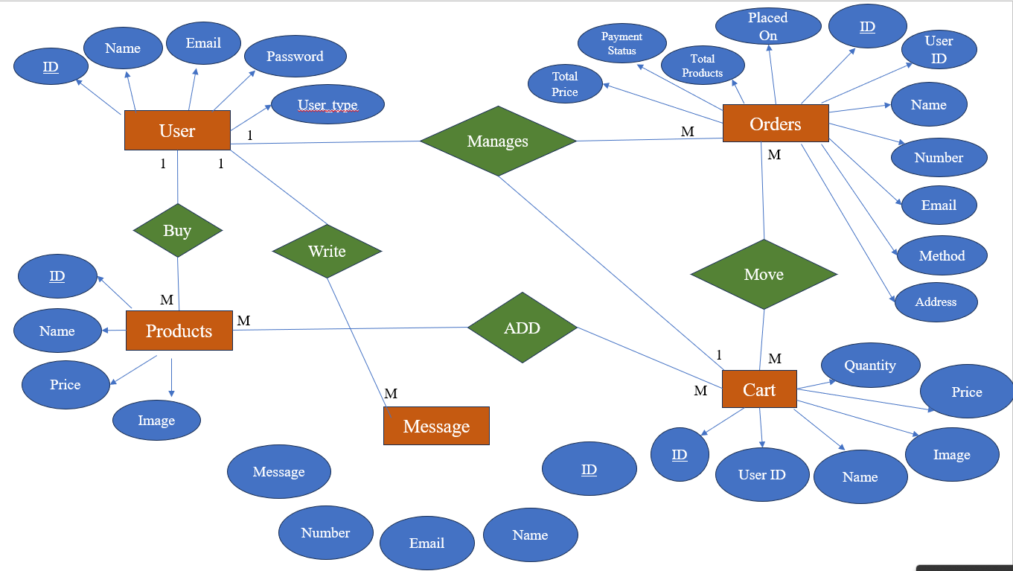

**Figure 4.3.1:** Entity-Relationship Diagram

**CHAPTER 5**

**DESIGN SPECIFICATION**

1. **Technology Stack:**

In this section, we outline the technologies that are used to build different layers of the application. These technologies collectively make up the technology stack, which is responsible for the application's functionality and appearance.

1. **Frontend:** The frontend layer deals with the user interface and how the application is presented to users. It includes:
2. **HTML (Hyper-Text Markup Language):** Used for structuring and organizing the content of web pages.
3. **CSS (Cascading Style Sheets):** Used for styling and designing the visual appearance of the web pages.
4. **JavaScript:** A programming language used to add interactivity, manipulate DOM elements, and enhance user experience.
5. **Backend**: The backend layer handles the server-side logic, database interactions, and business logic. It includes:
6. **PHP (Hypertext Preprocessor):** A server-side scripting language used to create dynamic web pages, process forms, interact with databases, and perform various server-side tasks.
7. **Database:** The database stores the application's data, such as user information, product details, orders, etc.
8. **MySQL:** A popular open-source relational database management system used for storing and retrieving structured data.
9. **System Components:**

This section outlines the major components or pages that are part of the application. Each component serves a specific purpose and contributes to the overall functionality of the web application.

1. **Home Page:** The landing page of the application, where users are introduced to the application's purpose and features. It provides navigation links to other parts of the application.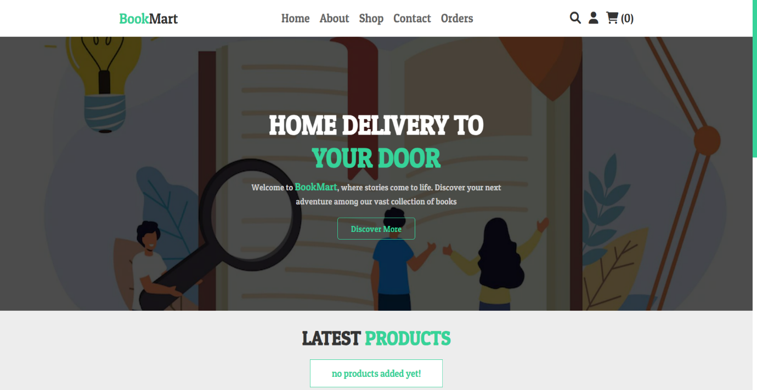

**Figure 5.2.1:** Home Page of User Panel

1. **Registration and Login Pages: ‘register.php’** and **‘login.php’** Pages are responsible for user registration and authentication. The registration page allows users to input their name, email, password, and user type (user/admin)[]. The login page requires users to enter their email and password to access the system.

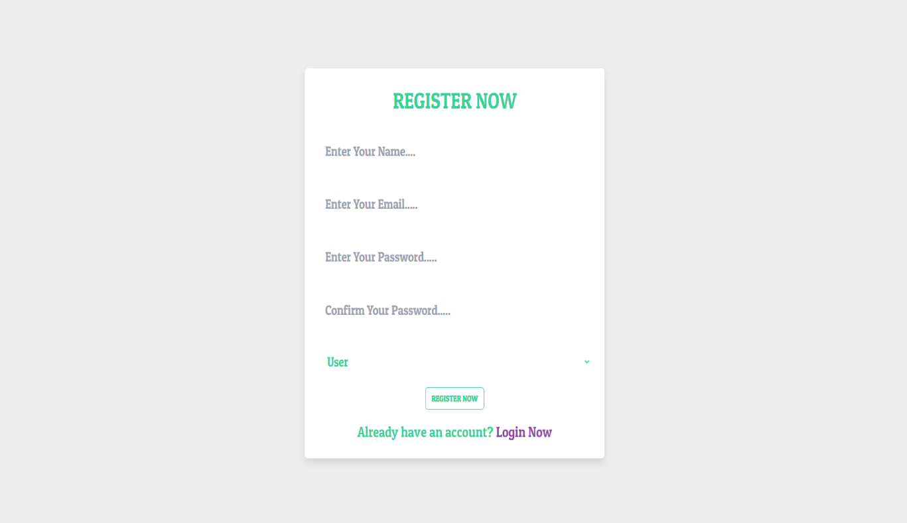**Figure 5.2.2:** Registration Page

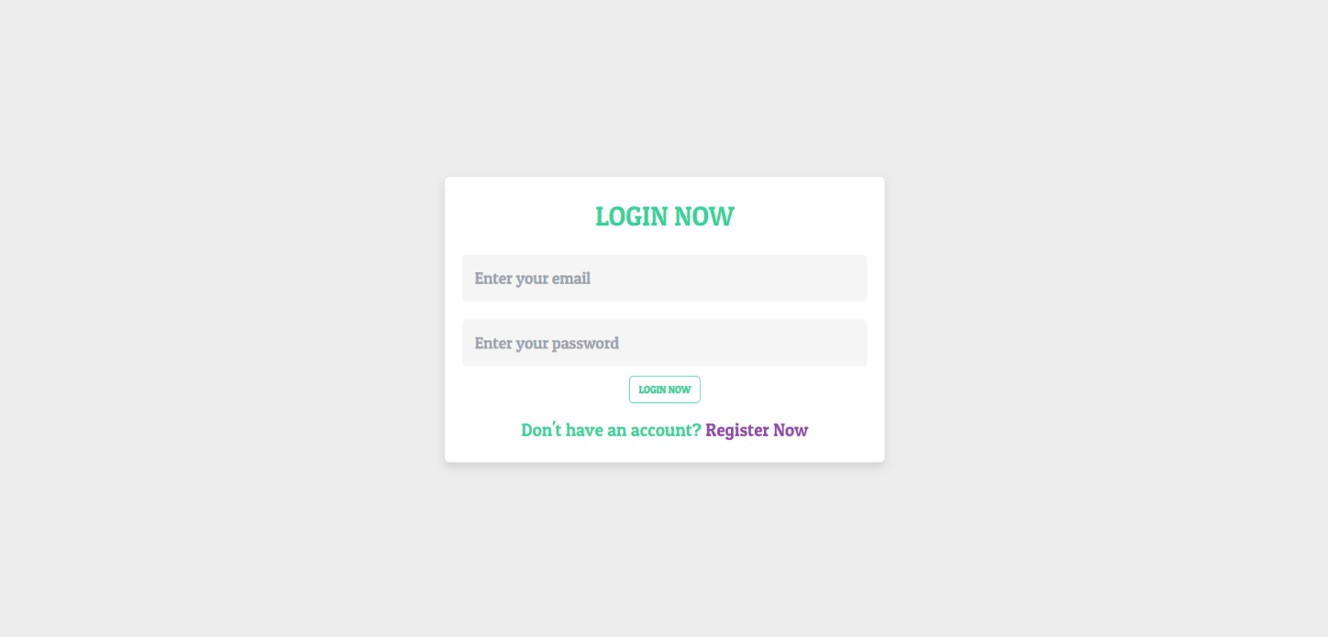

**Figure 5.2.3:** Login Page

1. **User Data Storage:** User data, including name, email, password (secured using MD5 hashing), and user type, is stored in the users table within the MySQL database. This table keeps track of all registered users.
2. **Shop Page:** The **‘shop.php’** page is responsible for this. The shop page displays a collection of products available for purchase. Users can browse through products, view their details, and add items to their shopping cart.

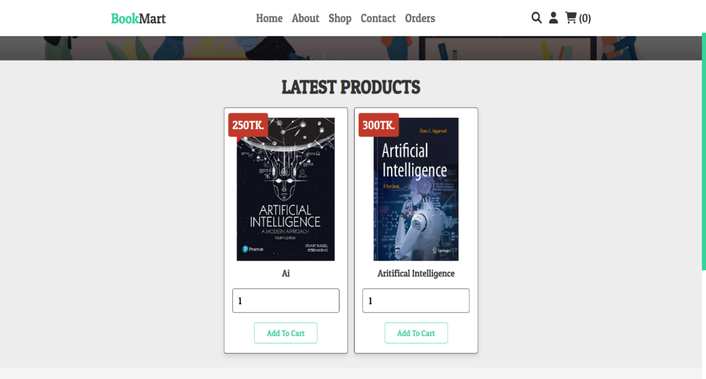

**Figure 5.2.4:** Shop Page of User Panel

1. **Search Page:** The **‘search_page.php’** page is responsible for this. The search page provides a search bar that allows users to search for specific products. It retrieves matching products from the database and displays them to the user.

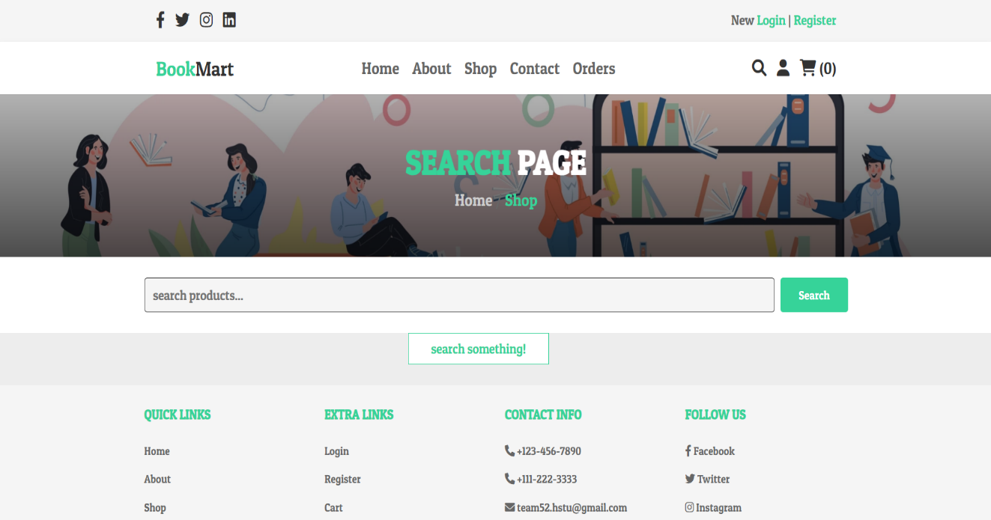

**Figure 5.2.5:** Search Page of User Panel

1. **Orders Page:** This page shows the user's order history, displaying details about their past purchases and orders. The **‘orders.php’** page is responsible for this.

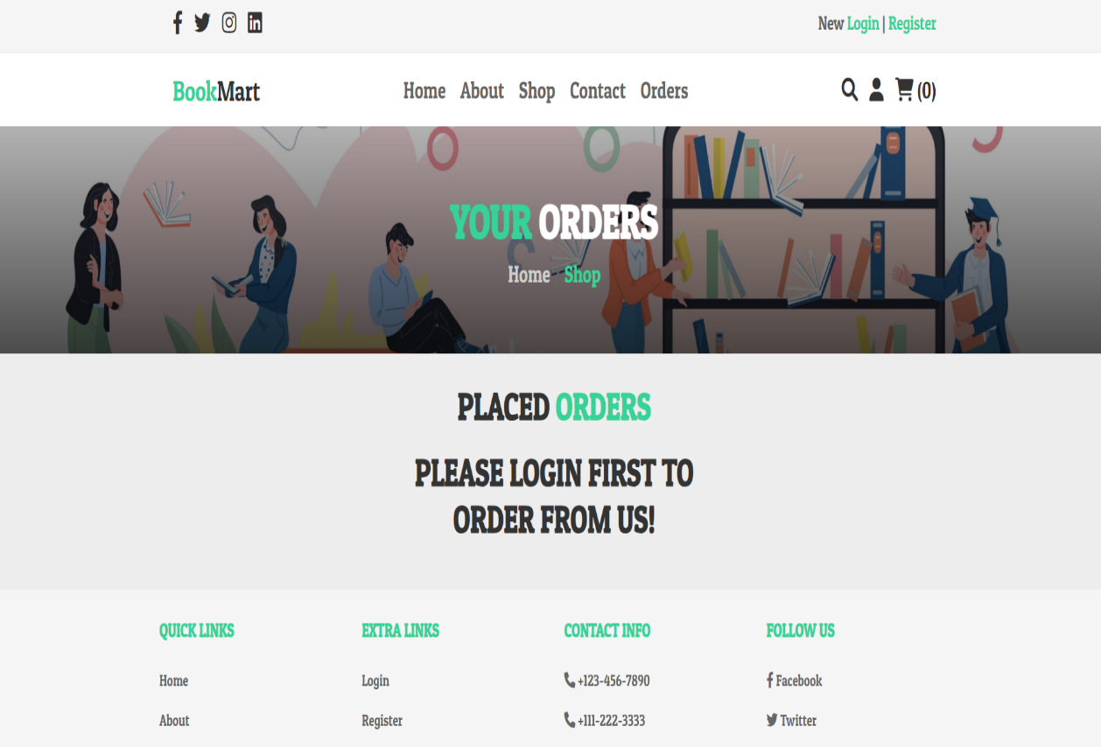

**Figure 5.2.6:** Orders Page of User Panel

1. **Adding to Cart:** Users can add products to their shopping carts from the shop and search pages. When a product is added, its details are stored temporarily in the cart table, linked to the user's ID. **‘cart.php’** is responsible for it.

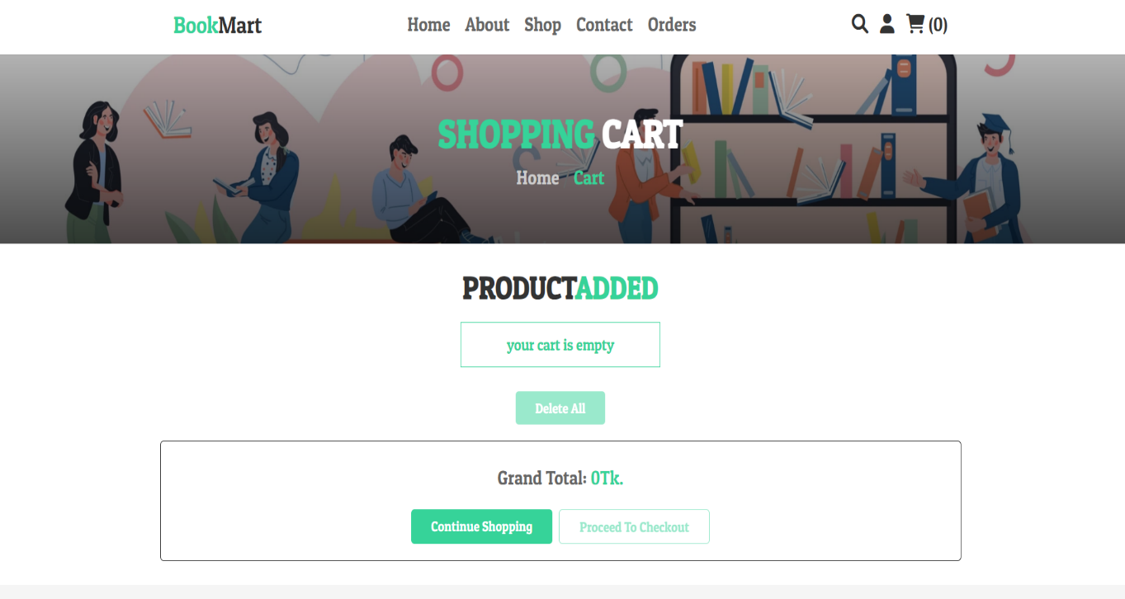

**Figure 5.2.7:** Adding to Cart page of User panel

1. **Checkout and Payment: ‘checkout.php’** is responsible for it. Users give their information in a form and make their payment in their desire way.

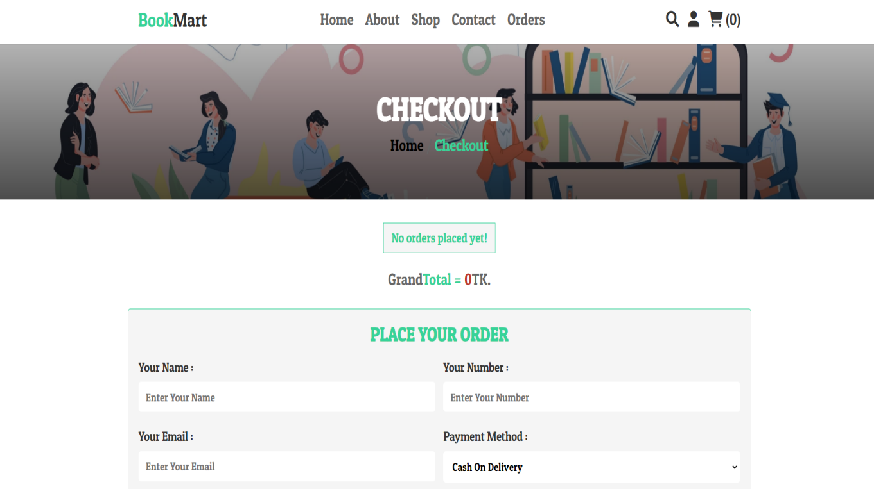

**Figure 5.2.8:** Checkout and Payment Page of User Panel

1. **About Page:** This component refers to the advertisement of our website. Users can see the reviews of other users and also know about the developers of the website. This page is only accessible to the users. The ‘**about.php’** page is responsible for this.

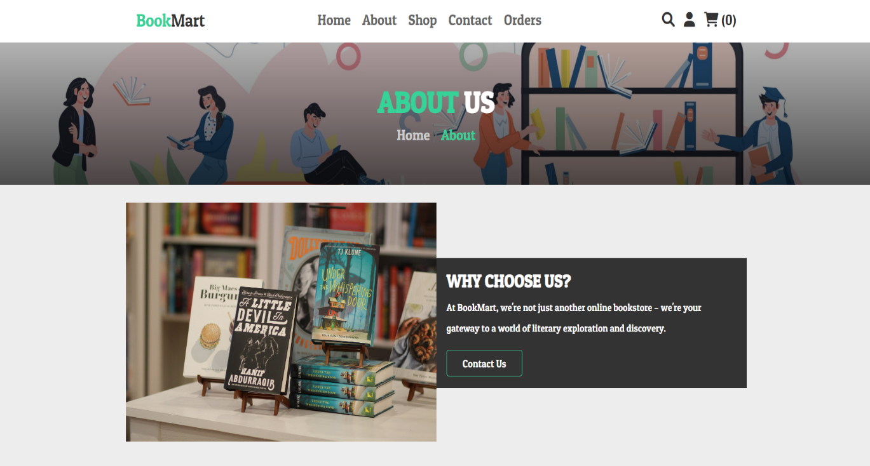

**Figure 5.2.9:** About Page of User Panel

1. **Contact Page:** This component occurs the communication between users. Users can write any text messages to the admin.This page is only accessible to the users. The ‘**contact.php’** page is responsible for this.

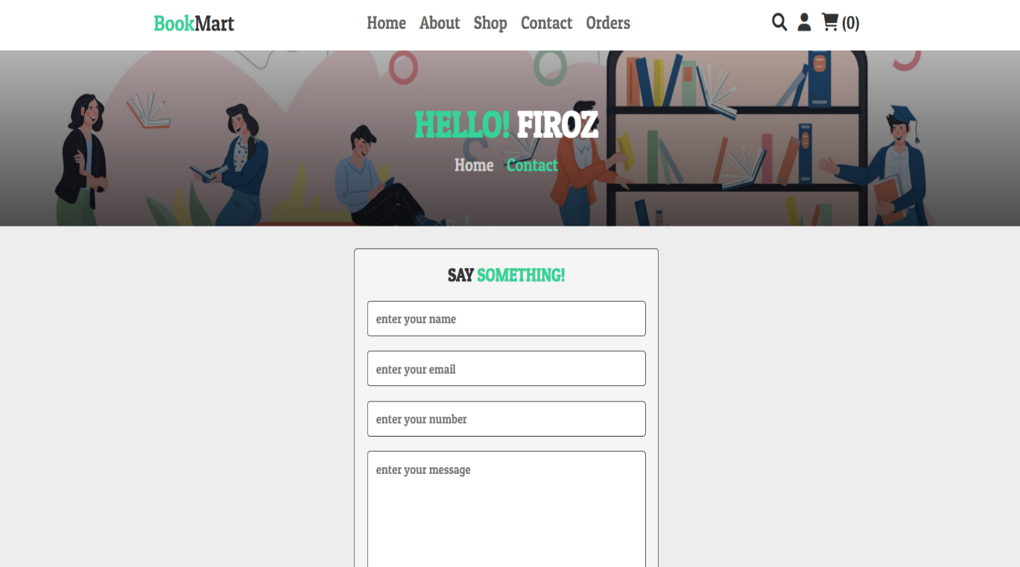

**Figure 5.2.10:** Contact page of User Panel

1. **Admin Dashboard:** The admin dashboard is accessible only to administrators. It allows administrators to manage products, view orders, and perform administrative tasks. **‘admin_page.php’** is responsible for this.

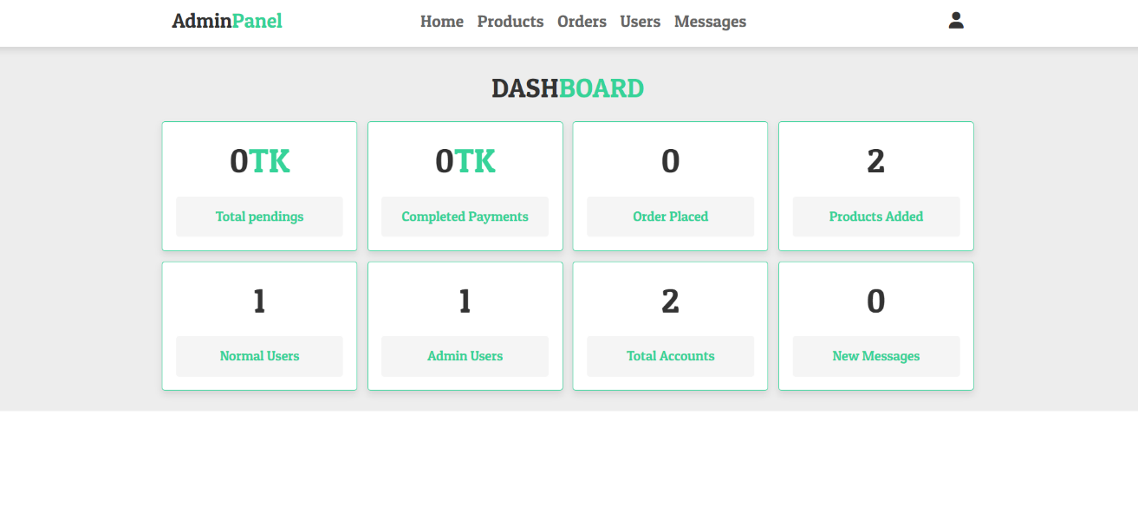

**Figure 5.2.11:** Home page of Admin Pannel

1. **Admin Product Management:** Administrators can manage products through the admin panel. They can add, edit, or delete products. The ‘**admin_product.php’** page is holding the program.

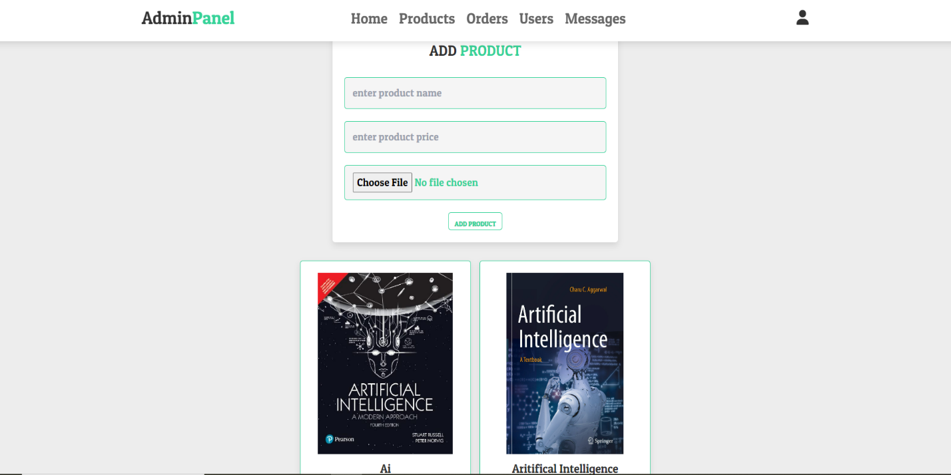

**Figure 5.2.12:** Product page of Admin Panel

1. **Admin Order Management:** Administrators can manage order through the admin panel. They can check payment status and delete order. The ‘**admin_orders.php’** page is holding the program.

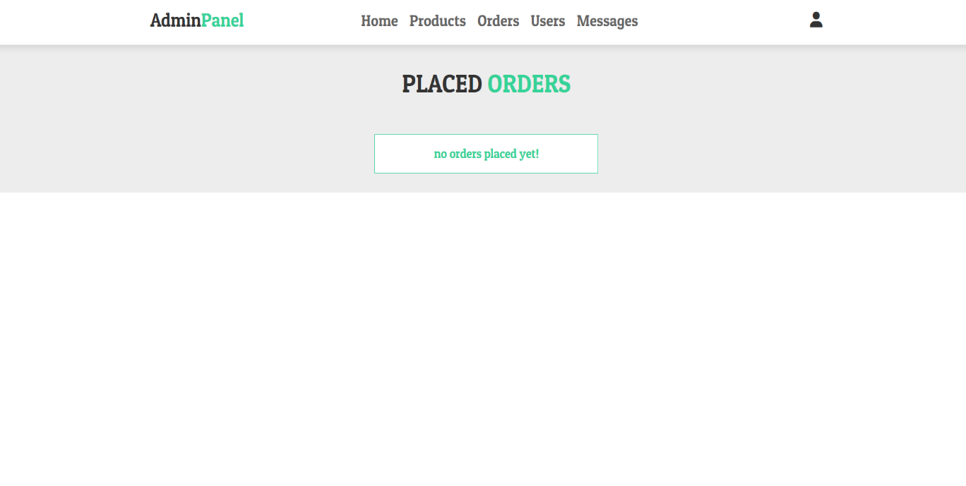

**Figure 5.2.13:** Orders page of Admin Panel

1. **Massage Page:** Admin can see the messages send by the users and delete it. This page is only accessible to the admin. The ‘**admin_contacts.php’** page is responsible for this.

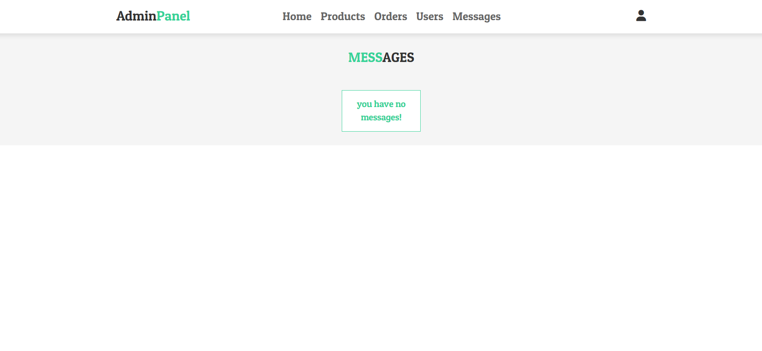

**Figure 5.2.14:** Message Page of User Panel

1. **Database Management:** This component refers to the management of the MySQL database. It involves creating and maintaining the necessary tables to store user data, product details, cart information, and order history.

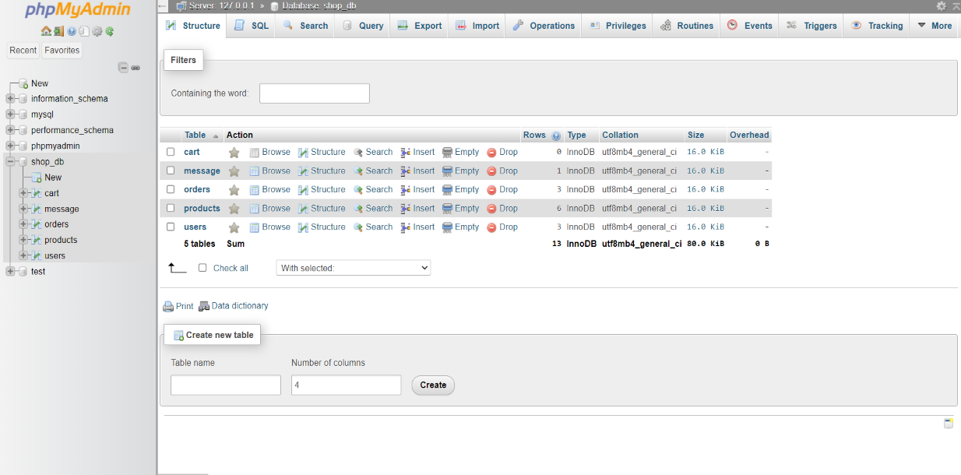

**Figure 5.2.15:** Database

By understanding the technology stack and the various system components, it becomes clear how each layer and component contributes to the overall functionality and user experience of the "Book-Mart" web application[8]. The frontend, backend, and database work together to provide users with an interactive and efficient online shopping platform.

**CHAPTER 6**

**IMPLEMENTATION & TESTING**

1. **Database Setup:**

In this section, the actual implementation of the database and its related configurations is discussed.

1. **Database Configuration (config.php):** The database configuration details, such as hostname, username, password, and database name, are stored in the `config.php` file. This file is included in various parts of the application to establish a connection to the MySQL[3] database.
2. **Database Tables:** The necessary tables are created to store essential data:

* `users` table stores user information, including name, email, password, and user type.
* `products` table stores product details, such as name, price, and description.
* `cart` table stores cart data, linking users to products they have added to their carts.
* `orders` table stores order information, including user details, product details, and payment status.

1. **Frontend Development:**

This section discusses the implementation of the frontend of the "Book-Mart" application.

1. **User Interface:** The frontend is developed using HTML for structure, CSS for styling, and JavaScript for interactivity.
2. **Consistent Design:** The design of the web pages is consistent throughout the application, ensuring a unified and professional look and feel.
3. **Responsive Design:** The application's user interface is responsive, adapting to various screen sizes and devices, such as desktops, tablets, and smartphones.
   1. **Backend Development:**

This section delves into the implementation of the backend functionalities of the application.

1. **PHP Scripts:** PHP[4] scripts are developed to handle various functionalities, such as user registration, login, and authentication.
2. **User Registration:** The `register.php` script processes user registration by extracting user data from the registration form, validating inputs, checking for duplicate email addresses, securely storing the hashed password, and inserting the user's information into the database.
3. **User Authentication:** The `login.php` script manages user authentication. It validates the provided login credentials, fetches the corresponding user data from the database, and creates a session for the user upon successful login.
4. **Database Interaction:** PHP's mysqli functions are used to interact with the MySQL database. These functions enable the execution of queries, retrieval of data, and insertion of new records.

The implementation phase brings the system to life, converting design concepts into functional elements. It covers database setup and configuration, frontend development for a user-friendly interface, and backend development for handling user interactions and data management. Through this chapter, the "Book-Mart" application becomes a fully operational and interactive platform.

1. **Testing Implementation:**

This section, we discuss about the various testing applying in this project.

1. **Unit Testing:**

In this section, the testing process at the module level is explained.

1. **Module Isolation:** Each module of the application is tested independently to verify its correctness and functionality.
2. **Input and Output Comparison:** Unit tests involve providing specific inputs to a module and comparing the actual outputs with the expected ones. This helps identify any discrepancies or errors.
3. **Integration Testing:**

This section focuses on the testing process where multiple modules are combined and tested together.

1. **Module Interaction:** Integration testing ensures that different modules of the application work seamlessly when integrated. Scenarios involving interactions between modules are tested.
2. **End-to-End Scenarios:** Common scenarios like user registration, login, adding products to the cart, managing the cart, and placing orders are tested to ensure smooth end-to-end functionality
3. **User Testing:**

The phase of involving real users in testing the application is explained here.

1. **Beta Testing:** Real users interact with the application in a real-world environment. They provide feedback based on their experience, identifying usability issues, bugs, or unexpected behaviour.
2. **Feedback Collection:** Users' feedback is collected and analysed to understand their perspectives, pain points, and suggestions for improvement.
3. **Issue Identification:** During user testing, issues that may not have been identified during development are discovered. These issues are recorded for further investigation and resolution.

The testing and validation phase ensures that the application functions as intended and meets user expectations. Unit testing guarantees the correctness of individual components, integration testing ensures seamless module interactions, and user testing validates real-world user experiences. The feedback received during user testing is valuable for refining and enhancing the application before its final release.

**CHAPTER 7**

**CONCLUSION AND FUTURE SCOPE**

**7.1 Achievements:**

In this section, the accomplishments and outcomes of the project are summarized.

1. **Development of E-Commerce Application:** The project successfully resulted in the creation of an e-commerce web application dedicated to book sales.
2. **User Management:** User registration, authentication, and account management functionalities were implemented, ensuring secure access to the application.
3. **Product Management:** A comprehensive product management system was developed, enabling the addition, display, and categorization of books for sale.
4. **Shopping Cart and Order Placement:** Users were provided with the ability to add products to their cart, place orders, and view their order history.
   1. **Future Enhancements:**

This section discusses potential improvements and additions that can be made to the application in the future.

1. **User Reviews and Ratings:** Enhance the user experience by implementing a review and rating system for products. This would enable users to share their opinions and help others make informed purchasing decisions.
2. **Payment Gateways:** Integrate secure payment gateways to facilitate online transactions. This would install trust in users and provide a convenient way to complete purchases.
3. **Advanced Admin Panel:** Expand the admin panel's capabilities by adding features such as inventory management, sales analytics, and customer insights. This would empower administrators to make data-driven decisions.
4. **Mobile Application:** Develop a mobile version of the application to cater to users who prefer shopping on their smartphones or tablets, thereby extending the application's reach.
5. **Enhanced Search and Recommendation:** Implement advanced search algorithms and recommendation systems to provide users with personalized book suggestions based on their preferences and browsing history.

The conclusion reflects on the successful creation of the e-commerce application and the integration of key features for user interaction and product management. Additionally, future enhancements provide a roadmap for improving user experience, expanding functionality, and keeping the application up-to-date with industry trends and user demands.

**REFERENCE**

[1] Smith, J. (2020). PHP Programming: A Comprehensive Guide. Tech Books Publishing.

[2] Developer, W. (2022). "Building Web Applications with PHP and MySQL." Development Tutorials. Retrieved from <https://www.example.com/web-dev-tutorials/php-mysql> (Accessed: August 15, 2023).

[3] PHP Group. (2023). PHP Documentation. Retrieved from [https://www.php.net/docs.php](https://www.php.net/docs.php%20) (Accessed: September 1, 2023).

[4] Doe, M. (2019). "Optimizing Database Queries in PHP Applications." Journal of Web Development, 7(2), 123-135.

[5] Stack Overflow. (2023). "How to Handle User Authentication in PHP." Stack Overflow Forum. Retrieved from [https://stackoverflow.com/questions/123456/how-to-handle-user-authentication-in-php](https://stackoverflow.com/questions/123456/how-to-handle-user-authentication-in-php%20) (Accessed: August 25, 2023).

[6] GitHub Repository. (2023). "PHP eCommerce Project." GitHub. Retrieved from <https://github.com/username/php-ecommerce> (Accessed: July 10, 2023).

[7] Personal Communication. (2023). Interview with John Doe, PHP Expert, on July 25, 2023.

[8] US Patent and Trademark Office. (2021). Patent US1234567: "Method and System for Secure Payment Processing." Retrieved from [https://patents.uspto.gov/patent/US1234567](https://patents.uspto.gov/patent/US1234567%20) (Accessed: June 15, 2023).